[**Module 03 Lesson - Quantitative and Qualitative Data**](https://learning.rasmussen.edu/webapps/blackboard/content/listContent.jsp?course_id=_67422_1&content_id=_6076796_1&mode=reset)

**Reading -**

* *Data Visualization: A Successful Design Process*
  + Chapter 5. Taxonomy of Data Visualization Methods
    - Permalink: <http://go.oreilly.com/rasmussen-college/library/view/data-visualization-a/9781849693462/ch05.html>
* *Storytelling with Data: A Data Visualization Guide for Business Professionals*\
  + Chapter 6. Dissecting model visuals
    - Permalink: [http://go.oreilly.com/rasmussen-college//library/view/storytelling-with-data/9781119002253/c06.xhtml](http://go.oreilly.com/rasmussen-college/library/view/storytelling-with-data/9781119002253/c06.xhtml)
* [Data Storytelling: Using visualization to share the human impact of numbers](https://content.learntoday.info/Learn/QMB3300fw_Summer_17/qmb3300fw-summer-17/media/datastorytelling.pdf)
* [Getting Started with Calculations](https://content.learntoday.info/Learn/QMB3300fw_Summer_17/qmb3300fw-summer-17/media/getting_started_with_calculations_transcript.pdf)
* [Introduction to Table Calculations](https://content.learntoday.info/Learn/QMB3300fw_Summer_17/qmb3300fw-summer-17/media/intro_to_table_calculations_transcript.pdf)
* [Aggregate Calculations](https://content.learntoday.info/Learn/QMB3300fw_Summer_17/qmb3300fw-summer-17/media/aggregate_calculations_transcript.pdf)
* [Date Calculations](https://content.learntoday.info/Learn/QMB3300fw_Summer_17/qmb3300fw-summer-17/media/date_calculations_transcript.pdf)
* [Logic Calculations](https://content.learntoday.info/Learn/QMB3300fw_Summer_17/qmb3300fw-summer-17/media/logic_calculations_transcript.pdf)
* [Number Calculations](https://content.learntoday.info/Learn/QMB3300fw_Summer_17/qmb3300fw-summer-17/media/number_calculations_transcript.pdf)

Visualizing Different Types of Data

This lecture will focus on visualizing different types of data. You will gain an understanding the importance of calculated fields in data visualization as well as presenting quantitative and qualitative data. Emphasis is placed on handling of zero fields, nulls, time between dates, and calculated fields in data visualization tools. This discussion will be followed by a review of quantitative and qualitative data sets.

**Calculated Fields**

This week the importance of calculated fields will be stressed. You may be wondering why the discussion centers around calculations as opposed to data visualization. Well, they go hand-in-hand. The source data will need to be manipulated in order to generate new insight, or perform an adhoc analysis. This is commonly done in MSExcel by clicking into a cell then typing the equals key “ = “ followed by a formula. Excel contains many standard functions that are already stored. For example, the =SUM function adds a string of values or cells that you define. This function and many others are useful when performing calculations on your data set. In data visualization tools such as QlikView and Tableau, calculated fields are also used. In Tableau, for instance, a calculated field can be created in your Tableau workbook. But please note that this calculated field will only be part of your Tableau environment and will not become part of your original dataset or data source. Please take a moment to read the “Getting Started with Calculations” and “Intro to Table Calculations” resource handout from Tableau.

**Zero Values, Nulls, and #N/A**

Another issue you will face in dealing with data is how to represent zero values, null values, and #N/A in your visualization. It is critical that you first understand the source of the data and why these values appear in your original data set or calculated field. Zero values can be the result of a calculation, a rounded field, a binary result, or a value manually entered to replace a blank field. Check the source data to make sure you understand this. If the zero value is a calculation or rounded field, determine if it is relevant to include decimal points. If the zero value is a binary number, then it can possibly be representing a field where the only valid results are 0 or 1. Sometimes this is used as a counter or to indicate Yes=1 and No=0 in a dataset.

**Formatting**

Formatting of numbers should also be reviewed when working with data in MSExcel or any other data analysis program. Quite often in MSExcel, numbers stored on a spreadsheet will have a format that is something other than a number. Even though the data appears as a number in a spreadsheet does not mean that it is formatted as a number, be sure to check. Numerical values in a spreadsheet can be formatted as text, general, date, or some other custom format. For example, when a person shares a data source from a large file containing lots of formulas, they often copy and paste the data over itself as values, which retains the values you see in the spreadsheet, but removes the calculations used the obtain those values. This can cause problems when importing that data as a source in your data visualization tool if it is not formatted properly.

**Time Between Dates**

Another function you should become familiar with is how to calculate the difference between dates in your data set. You may be doing this is MSExcel, or using a data visualization tool which automatically does this for you. It is important to be sure that the source data is properly formatted as a date field so that the correct calculations can be done. When working on a project or project schedule, you may have the need to measure how long it is taking to complete a particular milestone or some other metric. In MSExcel you can calculate this using a =DateDIFF function. This function will calculate the difference between two date fields and show the number of days between the two.

The following Tableau handouts are supplementary to this lecture.

* Introduction to Table Calculations
* Aggregate Calculations
* Date Calculations
* Logic Calculations
* Number Calculations

**Quantitative vs. Qualitative Data**

Previously we discussed the difference between continuous and discreet data. Continuous and discreet data are both forms of quantitative data. Data is divided into two categories, either quantitative or qualitative. Quantitative data is numerical. It is usually represented by data you can count, or measure. For example, you can count the number of cars a dealership sells in a given month. This would be discreet. Of you plotted the daily high temperature over a year, this would be considered continuous data.

Qualitative data is descriptive. It usually is represented by words that describe something. For example, the color of a house, the texture of carpet, or the material a shirt if made of. Often you will find that both quantitative and qualitative data are used to represent something. Going back to the shirt example, quantitative data can be used to describe the neck size like 17, or sleeve length like 34/35. The qualitative data about the shirt would be the color (blue) and cuff (French cuff). As you can see, the quantitative data is numerical and the qualitative data is descriptive using words.

When presenting or visualizing data, you will need to understand the purpose of your visual communication. You will choose the best method to present data based upon the type of data contained in your data set. You have to understand the need you are trying to meet with your audience. This will influence your choice in presenting data. If you are working for a department store and need to capture shirts sold by size, then you will be looking for quantitative data. If the objective is to understand the number of blue shirts sold, then the size won’t matter, just the color which is qualitative. Both quantitative and qualitative data are used to provide insight to the business.

Module 03 Lab Lecture

The purpose of this lab lecture is to provide you with background and guidance to complete the Module 03 Lab.

A Business Dashboards is a concept which has been around for many years. The concept of a business dashboard is modeled after the dashboard in an automobile. It provides pertinent information and warnings about the function of the automobile. It is where the driver first looks to understand how the automobile is performing. Gauges are used to show speed, rpms, and fuel while lighted icons signal a potential problem. For instance, the engine light comes on when a fault has been detected.

Similar to the automobile, a business dashboard is intended to provide the drivers of the business with pertinent information about how the business is performing. Companies generally decide which KPIs (Key Performance Indexes) should be monitored on a regular basis. Then those KPIs are included in a reporting dashboard and produced on a regular interval. Note that dashboards can be interactive where they can be created at any time. Dashboards may also contain drill down capabilities where a summary of a category is presented and the drill down function would take the user to the source data which makes up the summary indicators.

Business dashboards often include bar charts, trend graphs, gauge graphs, and geospatial maps. But note that there are many options for creating dashboards. The features will depend upon the software program which is used. By viewing a dashboard, a user should have a quick snapshot of business performance which may prompt the user to make additional inquiries or drill downs.

There are several tools available on the market today which have the ability to create dashboards. Listed below are a few programs which have this capability:

* Tableau
* SAS
* MS Excel
* QlikView
* JMP
* Domo
* iDashboards
* Sisense
* Roambi

You will learn about the creation of dashboards using Tableau as part of this Lab assignment. Before attempting to build a dashboard in Tableau, take a moment to view the free tutorial available in the Tableau Learning Center. You will access the Dashboard and Stories video series and look for the video called [Building a Dashboard](https://www.tableau.com/learn/tutorials/on-demand/building-dashboard-9). That section will look like the image below:

*Figure L3-1 Tableau Video Building A Dashboard*

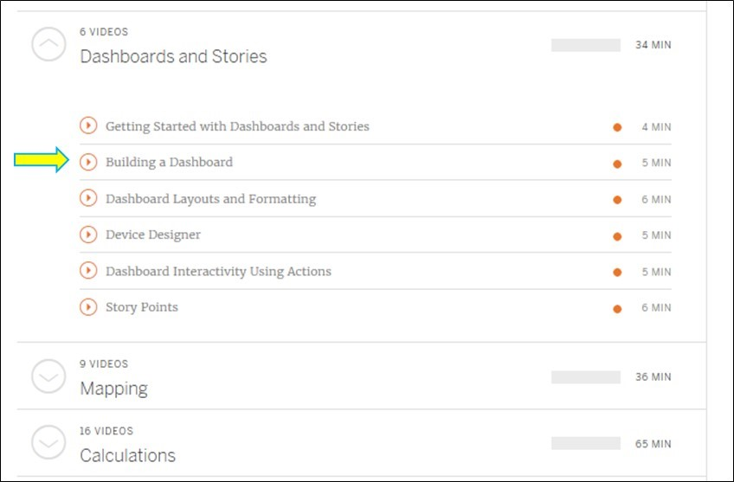

Once you view the video, you can proceed to complete the Module 03 Lab.